CONNECTED, LEVEL 3 2015, Fact or Fiction?  Pseudoscience  by Sophie Fern  Overview  We are constantly bombarded with messages about what science says is good for you. Often, the messages are from people who have an interest in our believing them. This article helps raise students’ awareness of the need to ask critical questions that enable them to separate real science from information that just sounds scientific.  A Google Slides version of this article is available at www.connected.tki.org.nz. |  |  | 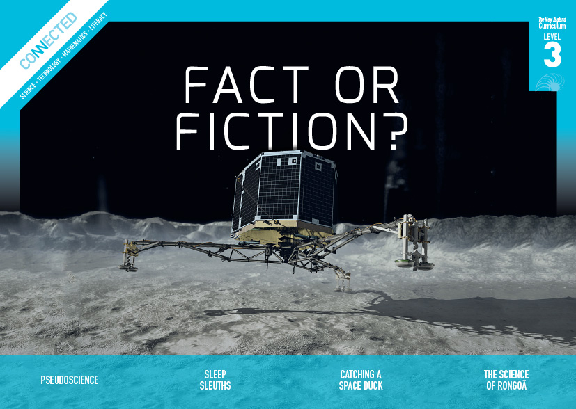  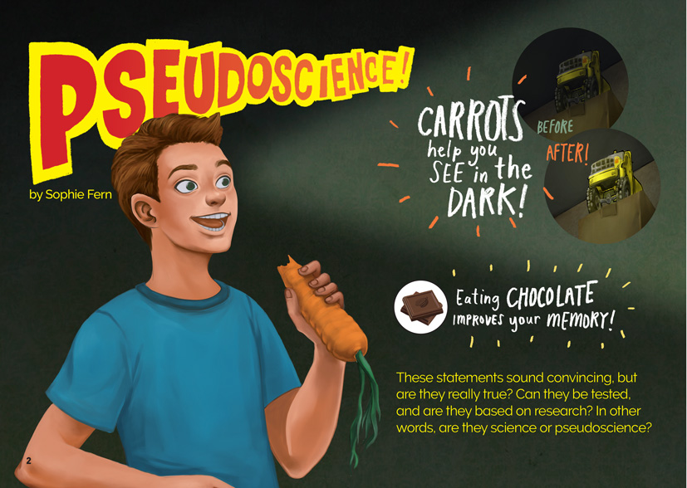
Science capability: Critique evidence |  | Text characteristics

Science knowledge is based on data derived from direct or indirect observations of the natural physical world. An inference is a conclusion drawn from those observations; it is the meaning you make from the observations. Understanding the difference between an observation and an inference is an important step towards being scientifically literate.  Being ready, willing, and able to critique evidence is also an important step towards being scientifically literate. Students must be able to assess the quality and reliability of both the observations (data) and the inferences made from those observations. In order to know what sorts of questions to ask to evaluate the trustworthiness of data, students need both methodological knowledge (how data is generated and collected) and statistical knowledge (how data is collated and analysed).  For more information about the “Critique evidence” science capability, go to http://scienceonline.tki.org.nz/Introducing-five-science-capabilities/Critique-evidence |  | - A mixed text type that includes a procedure and examples from the language of advertising.  - Abstract ideas accompanied by concrete examples in the text that help support students' understanding.  - Illustrations, photographs with labels, breakout text, subheadings, and a glossary.  - A significant amount of subject-specific vocabulary.

Curriculum context

SCIENCE
NATURE OF SCIENCE: Understanding about science  Achievement objective  L3: Students will appreciate that science is a way of explaining the world and that science knowledge changes over time. |  | NATURE OF SCIENCE: Communicating in science  Achievement objective  L3: Students will engage with a range of science texts and begin to question the purposes for which these texts are constructed. |  | NATURE OF SCIENCE: Participating and contributing  Achievement objective  L3: Students will use their growing science knowledge when considering issues of concern to them.  Key science ideas  Scientists:  - evaluate the trustworthiness of data by asking questions about investigations carried out by others  - undertake more than one trial to provide sufficient evidence to support a conclusion  - replicate investigations to critique the evidence or data provided by other scientists  - check that there are enough samples to reliably establish a conclusion  - look carefully at the way data has been collected when they consider investigations done by others.

ENGLISH

READING  Ideas  Students will show a developing understanding of ideas within, across, and beyond texts. |  | INDICATORS  - Uses their personal experience and world and literacy knowledge confidently to make meaning from texts.  - Makes meaning of increasingly complex texts by identifying main and subsidiary ideas in them.  - Starts to make connections by thinking about underlying ideas in and between texts.  - Makes and supports inferences from texts with increasing independence. |  |  |  | THE LITERACY LEARNING PROGRESSIONS  The literacy knowledge and skills that students need to draw on by the end of year 6 are described in The Literacy Learning Progressions.

MATHEMATICS AND STATISTICS
GEOMETRY AND MEASUREMENT: Measurement  Achievement objective  L3: Students will use linear scales and whole numbers of metric units for length, area, volume and capacity, weight (mass), angle, temperature, and time. |  |  |  | Key mathematics ideas  Data can be used for different purposes.

Critiquing evidence

The science capability “Critique evidence” is about students evaluating the quality of the data supporting a scientific claim or idea (http://scienceonline.tki.org.nz/Introducing-five-science-capabilities/Critique-evidence).
Scientists use empirical evidence to develop theories about how the world works.
Empirical evidence is data gathered from observations, experiments, and investigations.
Scientific claims are only as dependable as the evidence on which they are based.
Scientists design their investigations carefully to ensure that the data they gather is both reliable and valid. Valid data is data that measures what it is supposed to measure – it answers the research question. Reliable data is dependable and consistent. Replicating the experiment and getting the same results makes us more confident the data is reliable.
To gather high-quality evidence that is reliable and valid, scientists measure accurately, keep conditions the same or control variables that might influence measurements or observations, repeat tests or investigations many times, investigate multiple examples, and/or use statistical sampling techniques to make their observations or data as representative and accurate as they can.
Students should be critiquing and evaluating the quality of data gathered from their own investigations by:
- engaging in a range of investigation types, exploring, comparing, classifying, identifying, seeking patterns, using models, making things to test ideas, and investigating systems so that they learn different ways to gather different types of data
- identifying ways to make the data they collect in their own investigations as accurate and reliable as possible
- suggesting and developing ways to control conditions or variables or keep things fair, repeating observations or measurements or tests, and developing appropriate sampling methods
- applying their developing understanding of statistics and probability (sampling, variability, and the exploration of relationships in multivariate data) when making decisions about sample size and repetitions, and when working with their data.
Students should also be encouraged to look for, consider, and critique methods and data underpinning scientific claims made by others. This includes critically examining the appropriateness of methods and the quality of evidence used to develop scientific claims in the media and other sources.
Teachers can:
- help students to be more critical consumers of science information by being explicitly critical themselves
- support students to identify correlations as evidence of a potential relationship, but not necessarily cause and effect
- ask questions such as:
  - Would this always happen?
  - How sure are you of your measurements?
  - How many times should you repeat these tests/measurements?
  - Is this a fair result?
  - What may have influenced the data?
  - Was there a big enough sample?
  - Does the data match the claim?
  - How much variation is there in your results? Why might that be?
- support students to evaluate how data is presented; for example, if data is presented graphically, is this done appropriately or is it misleading? (This draws on another science capability, Interpret representations.)
- support students to apply their understanding of statistics and probability when considering claims, evidence, and data.
- establish a science classroom culture by:
  - modelling and encouraging a critical stance
  - encouraging students to consider the quality and interpretation of data underpinning scientific claims
  - using media headlines to introduce learning conversations and demonstrate the relevance of critiquing evidence to everyday life.
A range of questions and activities designed to get students to critique evidence is available on the Science Online website: http://scienceonline.tki.org.nz/Introducing-five-science-capabilities/Critique-evidence

Meeting the literacy challenges

This text describes and explains the differences between how scientists and advertisers use facts when communicating to their audiences. Important scientific processes such as determining reliability and critiquing evidence are explained. Readers are required to integrate ideas across the text to reach an understanding of pseudoscience.
The following strategies will support students to understand, respond to, and think critically about the information and ideas in the text.
You may wish to use shared or guided reading, or a mixture of both approaches, depending on the reading expertise of your students and the background knowledge they bring to the text.
After reading the text, support students to explore the activities outlined in the following pages.

TEACHER resources

Want to know more about instructional strategies? Go to:
- http://literacyonline.tki.org.nz/Literacy-Online/Teacher-needs/Reviewed-resources/Reading/Comprehension/ELP-years-5-8
- “Engaging Learners with Texts” (chapter 5) from Effective Literacy Practice in Years 5 to 8 (Ministry of Education, 2006).
Want to know more about what literacy skills and knowledge your students need? Go to:
- http://literacyonline.tki.org.nz/Literacy-Online/Student-needs/National-Standards-Reading-and-Writing
- http://www.literacyprogressions.tki.org.nz/
“Working with Comprehension Strategies” (chapter 5) from Teaching Reading Comprehension (Davis, 2007) gives comprehensive guidance for explicit strategy instruction in years 4–8.
Teaching Reading Comprehension Strategies: A Practical Classroom Guide (Cameron, 2009) provides information, resources, and tools for comprehension strategy instruction.

INSTRUCTIONAL STRATEGIES

FINDING THE MAIN IDEAS
Introduce the text and TELL the students this text is about identifying what is and isn’t real science.
PREVIEW the text with the students. Using the title, headings, and pictures, ask the students to PREDICT what the author’s purpose might be.
- What do you notice about the headings? (Most are questions.) What does that suggest about the focus of this article?
- What do you think “pseudoscience” might mean?
Read pages 2 and 3 and PROMPT the students to respond to the questions about the accuracy of the two statements.
ASK the students to read the first two paragraphs on page 3. DISCUSS the description of pseudoscience in relation to their responses to the previous question.
As the students read, PROMPT them to IDENTIFY the features of science in contrast to those of pseudoscience and RECORD these features on a T-chart.
Science | Pseudoscience
Statements have been tested and based on research | Includes facts and figures, but they only tell part of the story
Focus the students on the instructions for the chip investigation and identify the features of a procedural text, including the subheadings, list of equipment, use of imperative verbs, and numbered steps. If you are conducting the first of the science activities below, the students can use this as a model for writing their procedures.
The final paragraph on page 7 is an important step in the investigation to find out whether low fat chips have more or less fat than regular chips. It requires students to read and interpret information contained in short lines, which may be tricky for some students. DIRECT students to the final paragraph on page 7 describing the process for comparing the two fat stains on the two pieces of paper. PROMPT them to identify the connecting words and phrases that help them to follow the description. For example: “You can…“, “If the stain…”, “You have…”, “To do this…”. If you are using a shared reading approach and the text is projected onto a smartboard or whiteboard, you (or the students) could circle or highlight these words.

DEALING WITH UNFAMILIAR VOCABULARY
Focus on the word “pseudoscience”. PROMPT the students to notice the way the author supports the reader to develop an understanding of its meaning.
- How does the author give clues about its meaning on page 2? (It is contrasted with the word “science”.)
- The author explains the meaning on page 3. Did it mean what you expected it to mean?
- Why does the author tell us the meaning of “pseudo”? How might knowing this help you in the future?
- The author helps develop our understandings by giving other examples of pseudoscience. How did this help you develop your understanding? Did you think of other examples?
Look again at the prefix “pseudo”.
- What other words have the prefix “pseudo”?
Most words beginning with “pseudo”, such as “pseudonym” and “pseudointellectual”, are rather obscure. Have them use their prior knowledge to infer a possible meaning, and then use a dictionary to check if they are correct. ASK each student to write a sentence using the word “pseudoscience”, “pseudonym”, or “pseudointellectual”. Have them peer-review their sentences, checking that they have used the words correctly. The best sentences could go on a class word chart. Over time, you could add any other words that the students discover that begin with the same prefix.
REVIEW the T-chart and identify the words it includes that tell us about what is important in doing science (for example, “data”, “accuracy”, “reliability”). Have the students work in pairs to create definitions of these words. Then have them vote on the best of these definitions to create a class glossary. Have the students work in groups to create a flow chart or poster showing the steps required to “do real science”. The chart should incorporate words from their glossary.
Explore the words “critical” and “critique” and their relationship to the root word “critic”. Create a concept map to show this relationship.
Critic
Definition
Example
Critical
Definition
Example
Critique
Definition
Example
PROMPT the students to think of other examples of words that are related to these concepts and other situations where it is important to think critically.

EXPLORING TEXT TYPES
Have the students REVIEW the article and their T-charts to construct a second chart contrasting the two text types of advertising and reporting a scientific procedure. PROMPT them to IDENTIFY the purpose of each text type, the content and language (for example, sweeping claims to get attention instead of providing solid evidence), and the design (for example, eye-catching font compared to simple, ordinary font). Suggest that they can find a lot of information they need for this activity in the illustrations.
 | Advertising | Reporting a scientific procedure
Purpose
Language
Design

Key science ideas
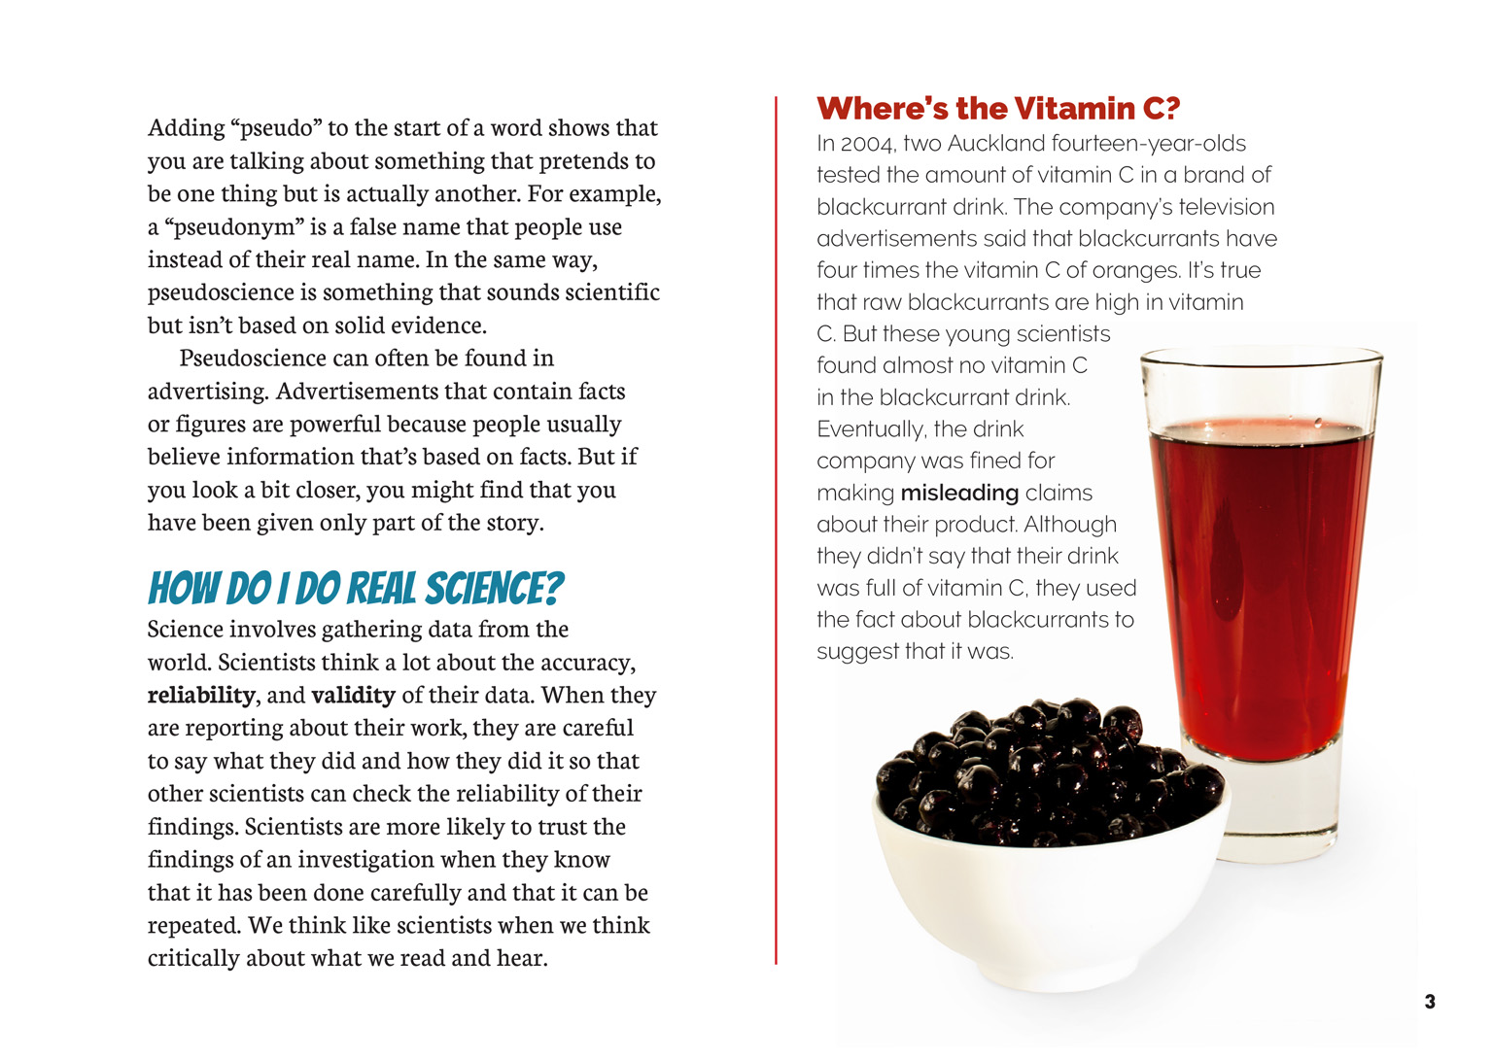 | Repeating the experiment and getting the same results makes us more confident the data is reliable.  Scientists critique data and scientific claims made by others.  Scientists evaluate how the data is presented; e.g. is it presented appropriately or is it misleading?
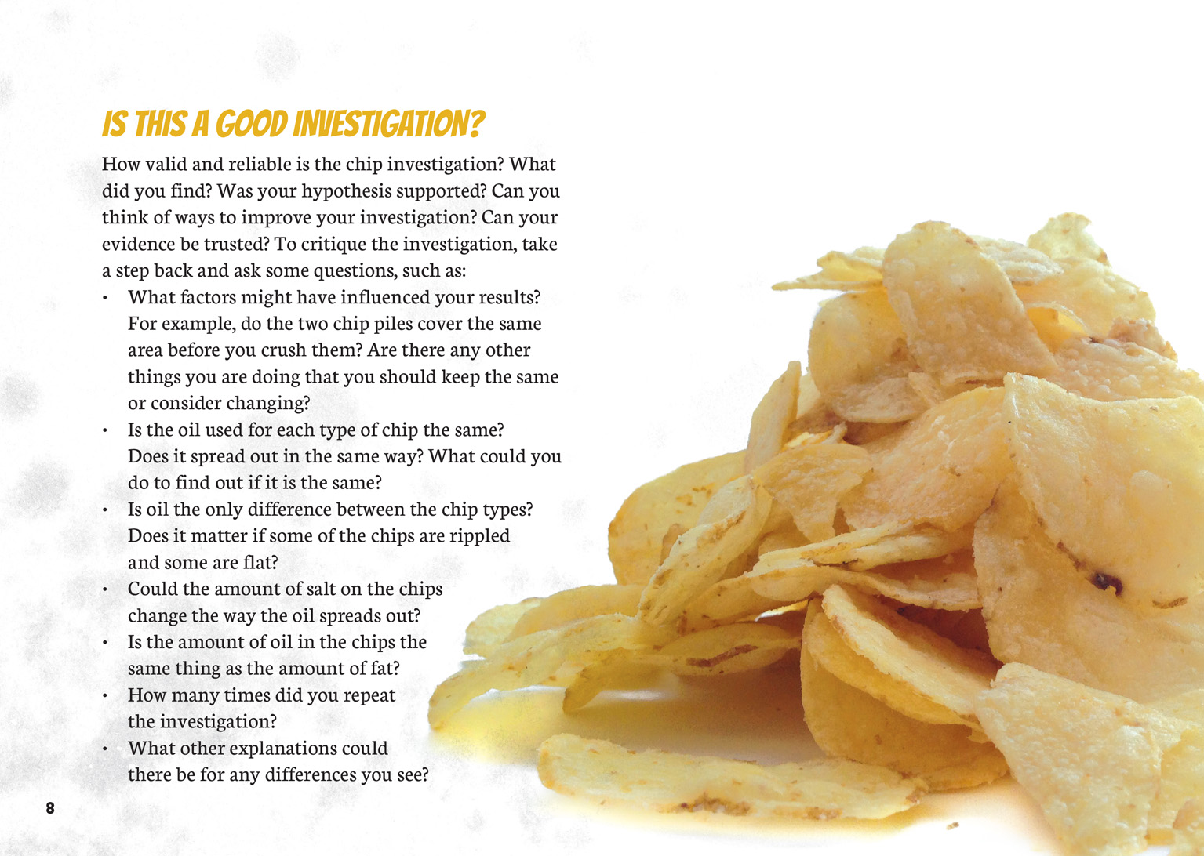 | Scientists keep conditions the same or control variables when planning investigations.  Scientists ask questions to evaluate the trustworthiness of data.  Scientists repeat tests or investigations many times to make their data as accurate as they can.

Learning activities
The following activities and suggestions are designed as a guide for supporting students to explore and develop understandings about the science capability “Critique evidence”. Some activities focus directly on the science capability. Other activities extend student content knowledge across the learning areas. You are encouraged to adapt these activities to support your students’ learning needs.

exploring the science

Activity 1: Is that right?
Have the students generate a list of statements about food and then interview their classmates and whānau members regarding whether the statements are fact or fiction and why. The students may find that the interviews generate more strong belief statements. (Note that this may lead to value statements about food and body issues, so you need to be careful. Keep the names of the informants anonymous.) The statements might include:
Brown sugar is healthier than white sugar.
Muesli bars are healthier than chocolate bars.
If it is fat-free, it must be healthy.
Fat-free is better than sugar-free.
Sports drinks are better than water when you’re exercising.
Eggs: nature’s perfect food.
Fish is brain food.
Collate and review the statements and have the students select a statement they want to test. Brainstorm the sorts of questions they would need to ask about these statements. For example: “What do we mean by brain food? Are some foods better for the brain than others? Is all fish good for the brain? Does it depend on how it is cooked?” Have them work in groups to design an investigation they can conduct to gather evidence. They should write their hypothesis and a procedure, modelling this on the example in the article. Explain that this process of design is often the hardest part of science and remind them that there are lots of ways of “doing science”. Their procedure may not involve an experiment. It might, for example, involve observations of how people respond to different types of food or an analysis of ingredients, using the information on the labels.
Remind the students of the “smart questions” for critiquing an investigation, set out on page 8 of the article. Have the groups present their investigation designs to each other and use the questions to critique them. They should then select one investigation to try, considering whether the proposed investigation is reliable and practical and whether the statement being questioned is one that interests them.
Have the class conduct the investigation that was selected and write up their findings. Together, they should critique their investigation, the method, conclusion, and how well their evidence supports their conclusion.
The investigations may leave the students with more questions that they wish to investigate, or they may want to let other people know that the statement they investigated is or is not supported by evidence. The latter might involve exploring the use of visual language to contrast truth with fiction and persuade people to make healthier and more informed choices.
Extension
The students could compare and contrast a range of snack foods to determine whether they fall into the category of healthy snacks and why. If they haven’t already done so, this would be an opportunity for them to explore the nutritional information on food labels and how this translates into reality. They could weigh out the amounts of sugar or fat listed in the labels and make a display showing how much sugar and fat is in a range of commonly eaten snack foods, for example, muesli bars, chips, and popcorn.

Activity 2: Fitter, healthier, stronger …
Discuss what the students have learned about how scientists generate data and assess its quality and reliability. You could reinforce this learning by taking them through the slides in “Working out what’s reliable evidence” (http://askforevidence.org/help/evidence).
Go online or look in magazines or newspapers to find some articles that make scientific claims and review them with the students.
What actual evidence is included in the article?
Is there enough evidence to support the claim being made?
Does the article say what the scientists actually did?
What more information would we need to know to be able to trust this claim?
Can we find the original work done by the scientists? What evidence did they produce? How? How does that compare with what is being claimed in the article?
Is this science or pseudoscience?
The infographic “A Rough Guide to Spotting Bad Science” (http://www.compoundchem.com/wp-content/uploads/2014/04/A-Rough-Guide-to-Spotting-Bad-Science-2015.pdf) highlights twelve common faults in scientific studies. You could unpack it with the students, changing the language to be more student-friendly. The students could then use the infographics to annotate the articles, creating exemplars that show people what they should look out for when evaluating claims that purport to be “scientific”.
The students can then transfer this learning to the claims made in advertisements. (Note that fashion magazines, magazines for keen sportspeople, and magazines from health stores and pharmacies provide a good source of articles that present scientific information to the general public). Have the students investigate the ways in which advertisers use pseudoscience to play on people’s anxieties and aspirations and to convince people to buy their products. Connect this to their learning in health and physical education about the way advertisers target people’s concerns about their health and body image.
How are we sold health and beauty products?
What is used to trigger our desire to buy?
The students could analyse a range of advertising claims before bringing their findings together in a series of “smart questions” that people should ask themselves before accepting claims in advertising. They could share these with others in their school, perhaps as a display on the classroom window or on the school Intranet.
Extension
The students could investigate different foods online, then create a headline or advertisement trying to trick their audience into buying something that may not necessarily be totally healthy but does have some nutritional value.

RESOURCE LINKS

“Fair Chocolate”. School Journal, Level 4 Nov, 2014, pp. 30–37.

Curriculum in Action
Healthy People Eat Healthy Food (Years 1–3), 1999. http://health.tki.org.nz/Key-collections/Curriculum-in-action/Healthy-people-eat-healthy-food
Choice Food! (Years 7–8), 1999. http://health.tki.org.nz/Key-collections/Curriculum-in-action/Choice-food!
“4 Examples of Misleading Health Ads” from Investopedia. www.investopedia.com/financial-edge/0612/4-examples-of-misleading-health-ads.aspx
“8 advertising tricks of the beauty industry” from allwomenstalk. http://allwomenstalk.com/8-advertising-tricks-of-the-beauty-industry/6/
“16 Most Misleading Food Labels” from Health.com. www.health.com/health/gallery/0,,20599288,00.html
“A Rough Guide to Spotting Bad Science” from Compound Interest. http://www.compoundchem.com/wp-content/uploads/2014/04/A-Rough-Guide-to-Spotting-Bad-Science-2015.pdf
“Chocolate consumption and Nobel Prizes: A bizarre juxtaposition if there ever was one” from Scientific American.http://blogs.scientificamerican.com/the-curious-wavefunction/2012/11/20/chocolate-consumption-and-nobel-prizes-a-bizarre-juxtaposition-if-there-ever-was-one/
“Chocolate weight-loss study was a fake, research troll reveals” from Stuff.co.nz. www.stuff.co.nz/life-style/well-good/teach-me/69061635/chocolate-weightloss-study-was-a-fake-research-troll-reveals
“Does dark chocolate’s epicatechin content promote muscle growth?” from Examine.com. http://examine.com/blog/does-dark-chocolates-epicatechin-content-promote-muscle-growth/
“Eggs: Health Benefits and Nutrition Facts” from Live Science. hwww.livescience.com/50834-eggs-nutrition-facts.html
“Sports Drinks” from Consumer. www.consumer.org.nz/articles/sports-drinks
“The 13 Biggest Nutrition and Food Myths Busted” from Eating Well. www.eatingwell.com/nutrition_health/nutrition_news_information/the_13_biggest_nutrition_and_food_myths_busted
“Which is the healthiest of NZ’s popular potato chips?” from Stuff.co.nz. www.stuff.co.nz/life-style/well-good/teach-me/67877211/which-is-the-healthiest-of-nzs-popular-potato-chips
“Working out what’s reliable evidence” from Ask for Evidence. http://askforevidence.org/help/evidence

exploring the MATHEMATICS AND STATISTICS

Activity 1: Making comparisons
The students could explore the method of calculating the amount of fat described in the article, which used the grids on graph paper. They could transfer this into an investigation into the amount of preservative in hamburger patties.
Which hamburger patty will take the longest time to go mouldy … and so has the most preservative?
How could we adapt the method in the article to this investigation?
How should we present our data so that we can make comparisons between the different bands of patties?
This could also be an opportunity for the students to explore the price of the patties and whether there is relationship between the cost of the patty and how healthy it is. Using the information on the labels, they could compare the cost against a range of variables, such as the:
percentage of meat
percentage of fat
percentage of protein.
As they conduct this activity, support the students to explore the different ways they could present their data.
How can we ensure we present our data so that it is easy to read?
What if we were a manufacturer trying to convince people that our patties are good for people? How might we present the data so that it is accurate but looks better than it really is?

Activity 2: The perfect patty
You could connect this learning to a technology activity in which the students aim to design a nutritious and tasty meat or vegetarian patty at an economic cost.
In the first phase of this inquiry, the students should focus primarily on nutrition and economics. They will need to present data to show both the nutritional value of the patties they have designed and their cost, organising it to show the trade-offs they have made between these two variables. They could then cook their patties and conduct a blind taste test. They will have to decide how they will organise their data so that they can compare the results of the taste test to their original findings. They may work through several rounds of this activity, experimenting to develop the ultimate low-cost, tasty, and nutritious patties. This work could be given greater purpose by being connected to an occasion when whānau and/or other community members are visiting the school.

Google Slides version of “Pseudoscience” www.connected.tki.org.nz

